  
  
  
Project 3   
  
**Project Three:** Path Planning Algorithms

ECE 5425-001

Siva Chinthalapudi

Rocky Saxena

Department of

Electrical Engineering  
  
Wayne State University  
  
Detroit, Michigan  
  
48202, USA

December 6, 2019

**Introduction:**

This report was created to showcase our work on our Path Planning project, this was the third and final project of the semester under the guidance of Professor Pandya. In this project we used MATLAB and downloaded 2 tool boxes Robotics Toolkit and the Vision toolbox to use for our project. In this we created an interactive GUI that allows for a pleasant experience. This report will go into the details of our project, it will talk about the approach of the project, our results and findings, and will also discuss our experience throughout the project.

**Methods:**

This project started with us figuring out how to use the Dstar and PRM algorithms, which was done by reading the robotics tool kit literature. Project 1 and 2 allowed us to get an insight on how to approach the path planning portion of the project. First, we had to download the vision tool box to allow us to use Dstar and PRM classes ( inherited from the navigation class), second we had to understand how TPOLY function works and how we could combine both this method and the path planning algorithms to allow our robot to draw smoother lines. We had to create the layout for the project which we used by using the Grid function in the toolbox. After creating the map of the maze, we needed to path plan so using the code we got Dstar to work and give us x and y coordinates. From here we wanted to graph this in our robot and GUI, for this we had to use mapping function which used the linear equation of a line y = mx +b to map our Grid which was 100 by 100 to the size of our clipboard and then using ikine and mapping those values we gave our servo motors the ability to graph our path planning algorithms and maze.

After we had created this portion of our project we had to use two push buttons to go back to the start, and throw an obstacle. So to accomplish this we used our knowledge from project 2 to use an if else statement in of for loops to allow us to throw an obstacle at any point in the path planning for both PRM and Dstar applications as well as go back from the point you’re at.

After coding our project we created a video that both Rocky and I participated to show our knowledge and understanding of the mechanisms used to get our project completed. We were able to complete all the objectives that were assigned to us in the project and have produced a 3:57 mins video for this Path Planning Project. To view our video please click the link below:

<https://www.youtube.com/watch?v=md7zKonyrdE>

**Results:**

GUI:

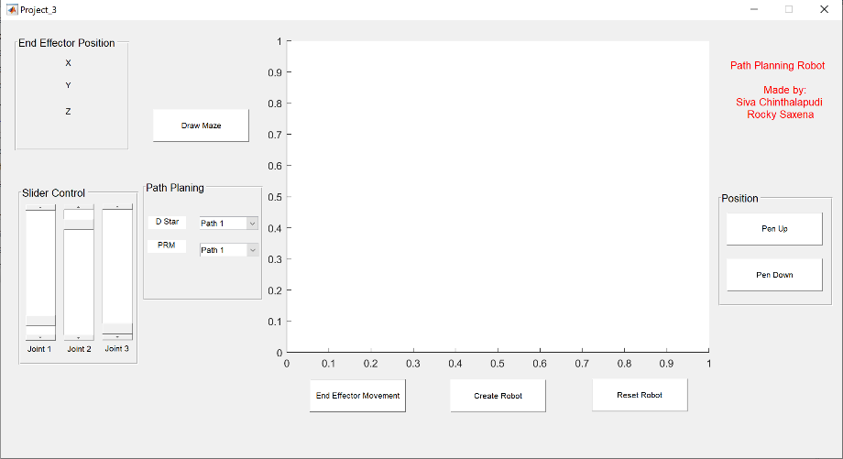

Dstar Path 1:

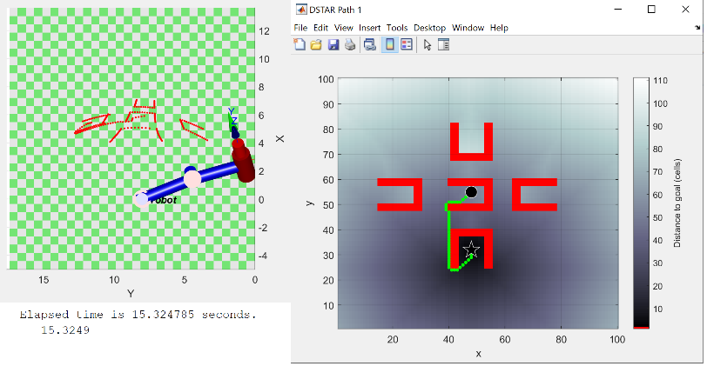

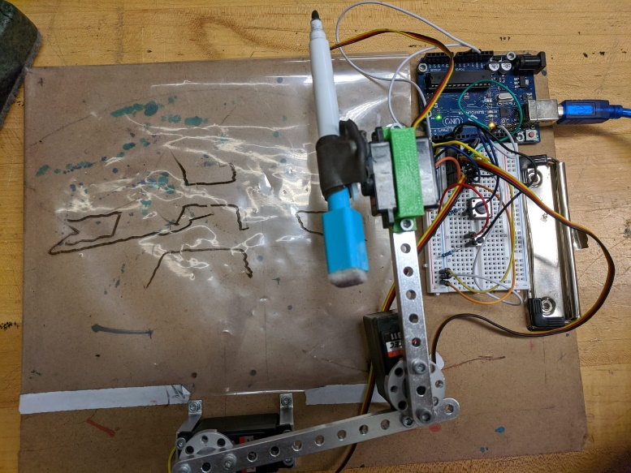

Dstar Path 2:

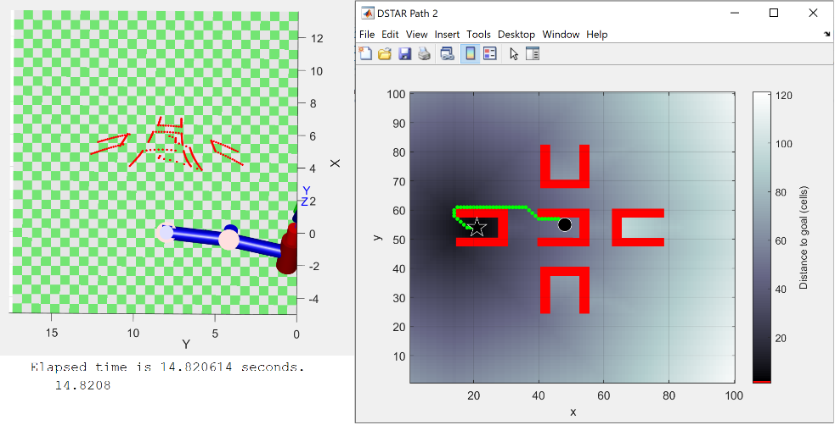

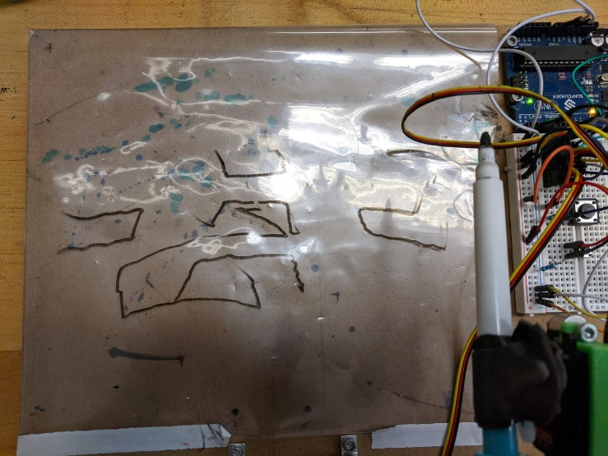

Dstar Path 3:

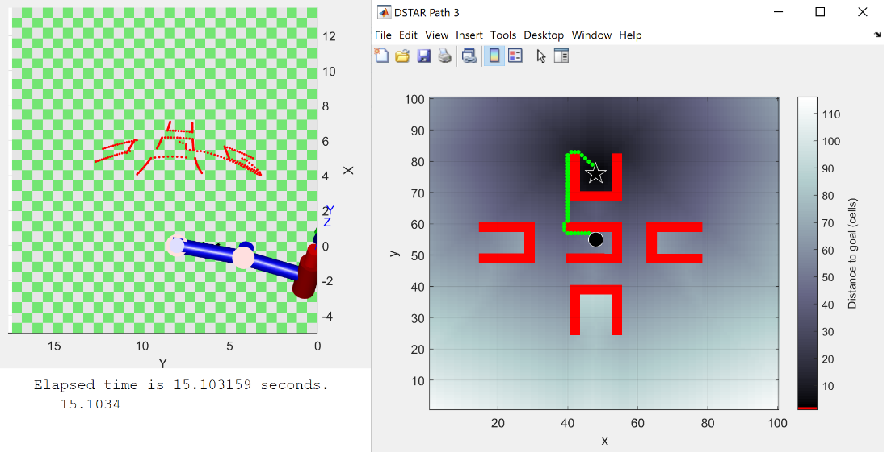

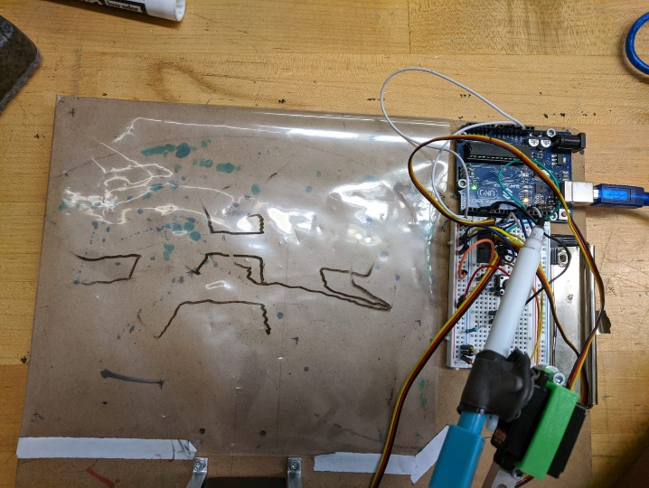

Dstar Path 4:

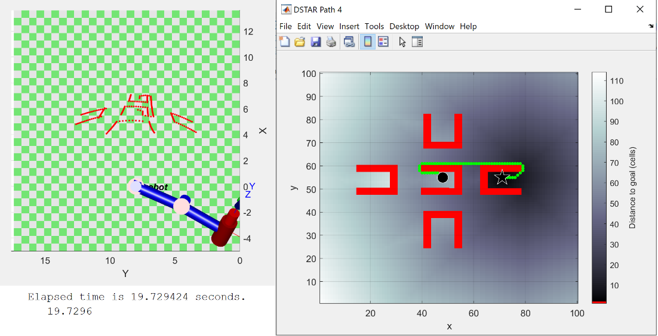

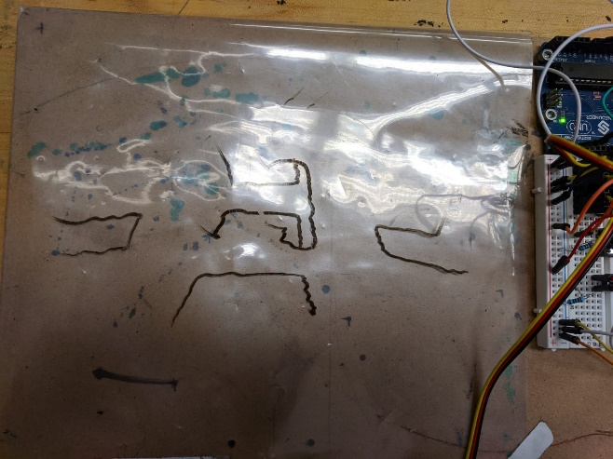

PRM (TPOLY) Path 1:

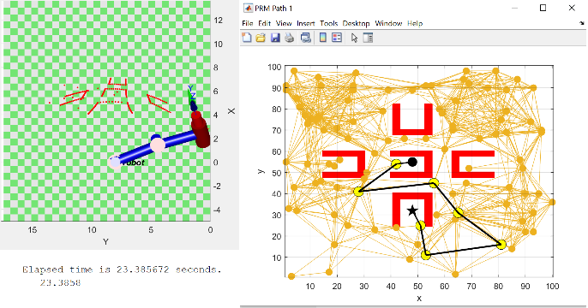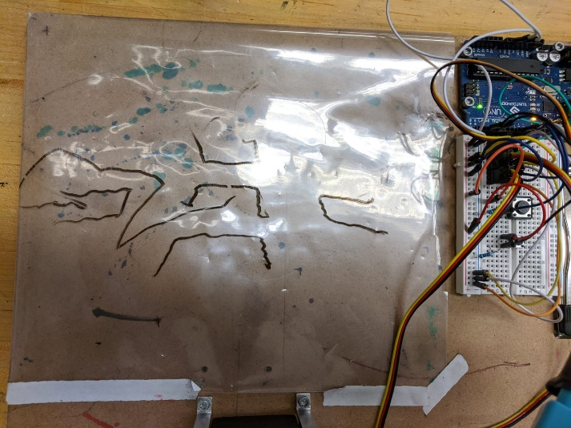

PRM (TPOLY) Path 2:

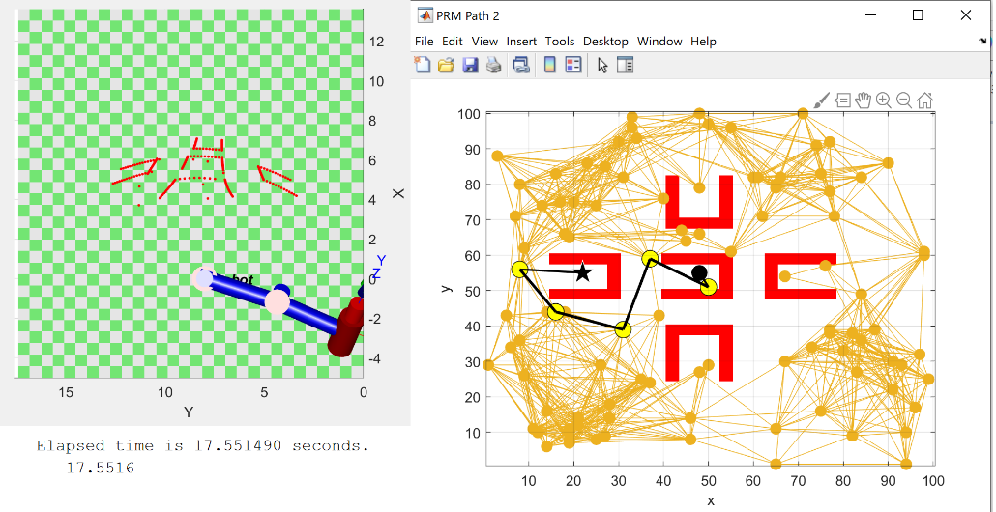

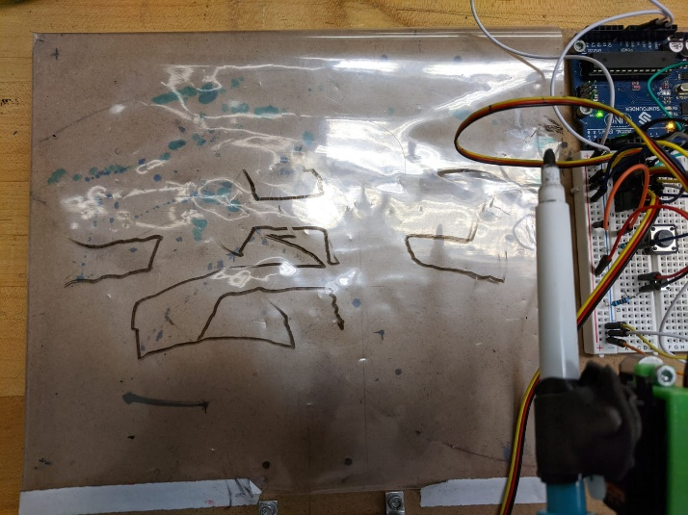

PRM (TPOLY) Path 3:

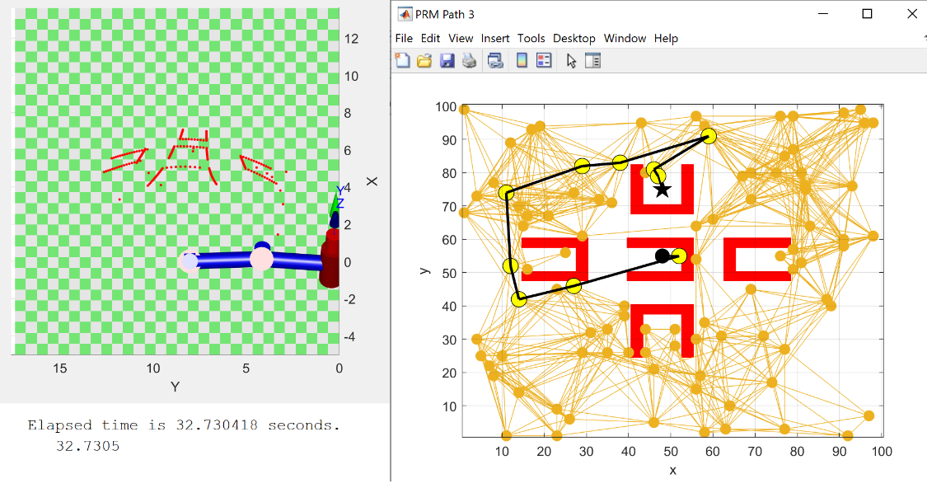

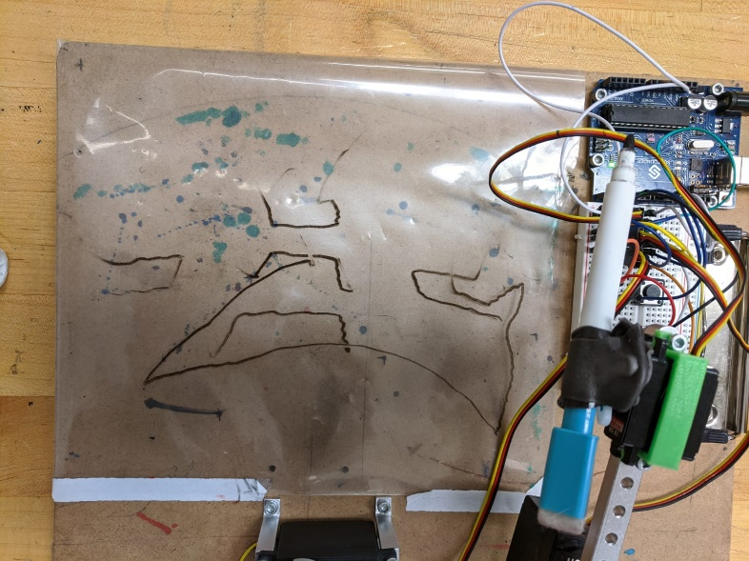

PRM (TPOLY) Path 4:

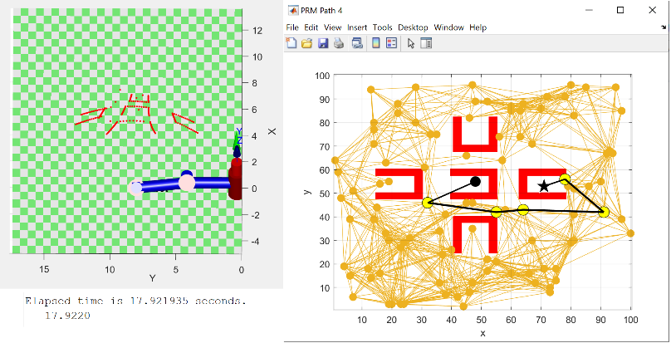

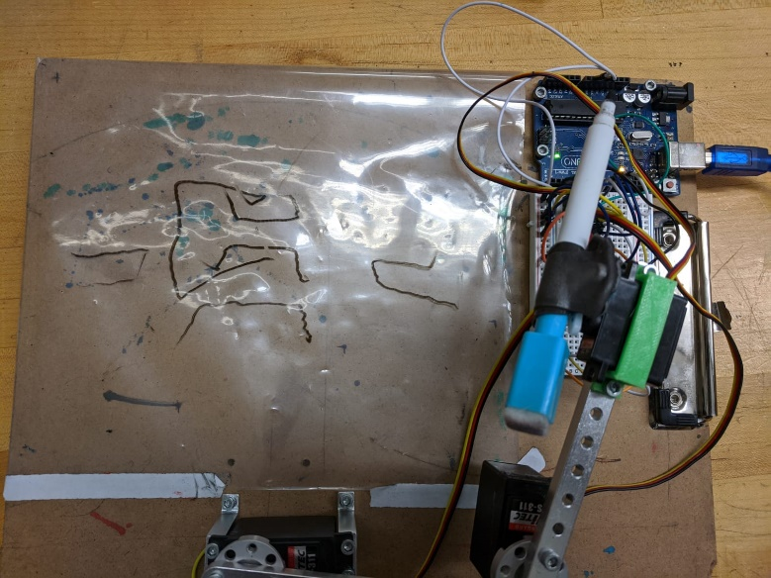

Dstar Path 1 (Go back to start) :

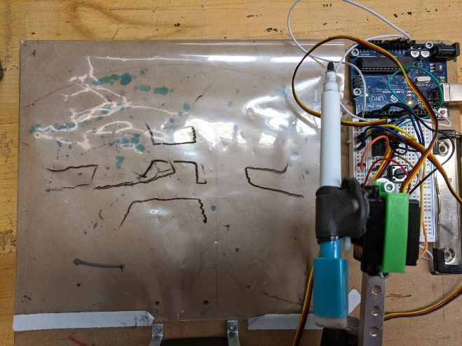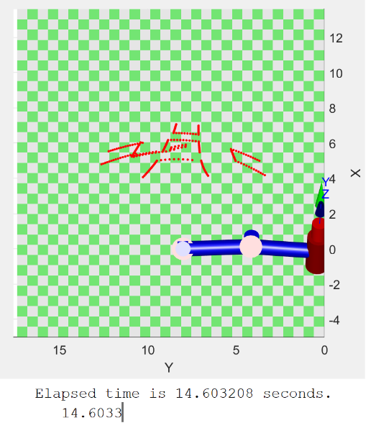

Dstar Path 2 (Throw Obstacle) :

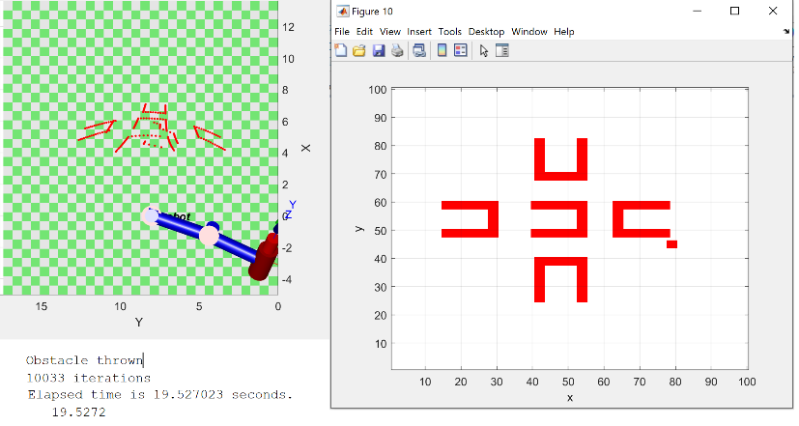

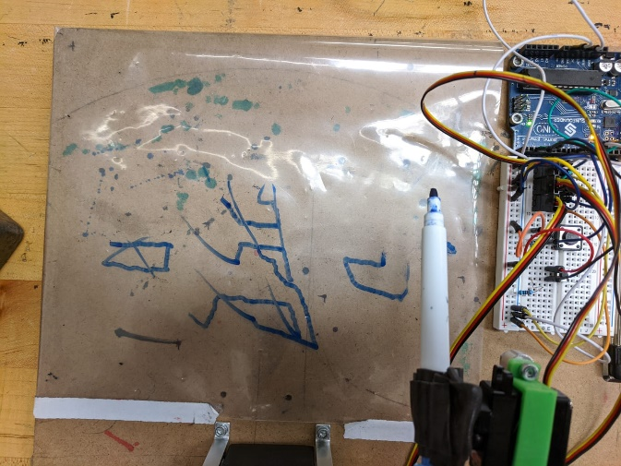

PRM Path 3 (Go back to start):

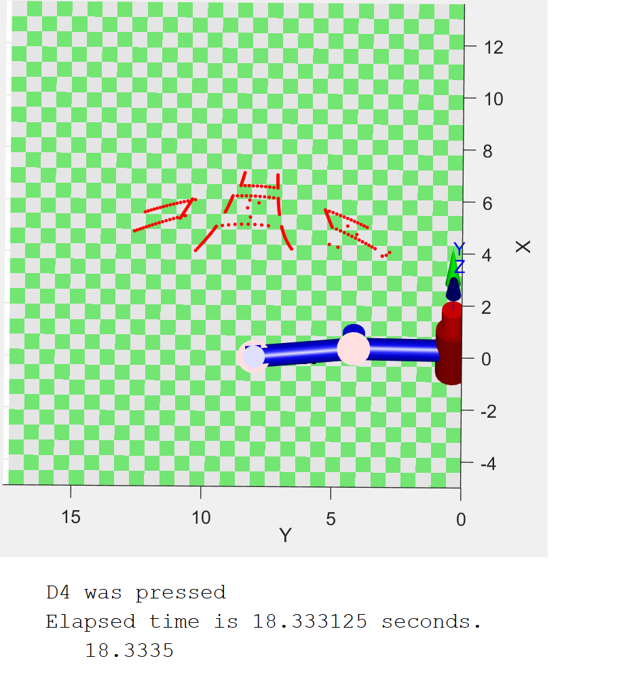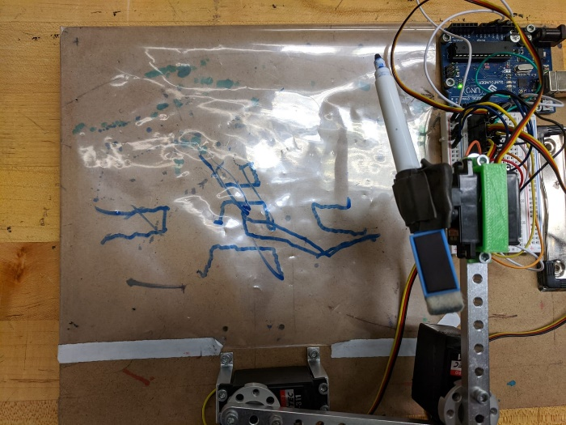

PRM Path 4 (Throw Obstacle):

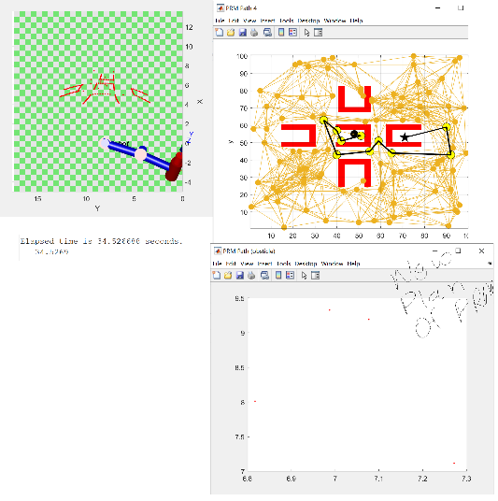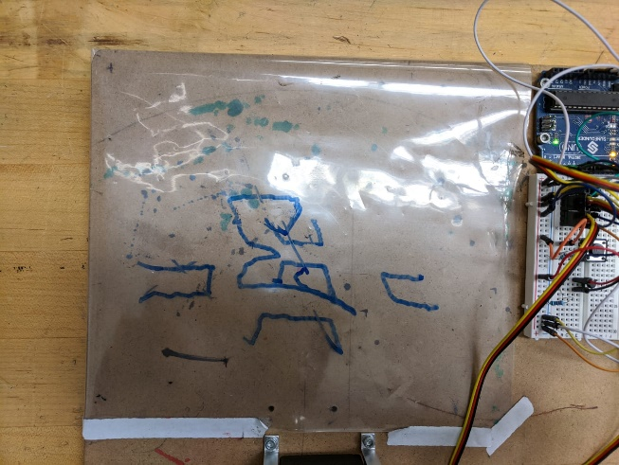

**Discussion:**

Over the time frame of the project, both Rocky and I struggled a lot to get this project done, though it was a straight forward project there were many obstacles that we had to overcome. A major issue in our process was not being able to linearly map grid values to board values, then map once more in servo values ( 0 to 1). However, once the mapping was figured out completing the project went smoothly.

After classes resumed and using the help from the professor, we had a small misunderstanding of the mapping function after realizing this, the rest of the project was smooth sailing as we were able to get all the other objective of the project. Overall we learned a lot from this project, this was our first time we struggled with an issue and this has allowed our thinking process to expand and this is what we will see in the future, with the way the industry is looking like, we have learned to struggle and use help of others to better ourselves and our craft to become better engineers.

**Conclusion:**

This project was a success with all the objectives of the project being achieved. We were able to successfully path plan with both algorithms, throw an obstacle in the path and have it re path plan, and send it back to start form its initial position. We had struggled in the beginning with our mapping function, but after jumping that hurdle, we were able to finish the project in a short period of time. This class has been one of the most helpful courses in the ECE/BME department learning hands on and getting dirty with the work has allowed both us to become better versions of ourselves.